Reconciliation & Verification Tool (Tool 1) — Build Plan (Phase 1 Product)
Oct 13, 2026 · @Unnati
The Phase 1 product is built in 10 sprints over 14 weeks by one developer working full time (8–9 hours a day) with Claude Code, with separate Claude agents for testing and peer review. It ends in a go/no-go decision after a pilot at the CA firm. Week 1 is strictly the reconciliation core: files in, hand-written rules, findings out, from the command line. Each sprint ends with working, tested code shown on test files.

Roadmap
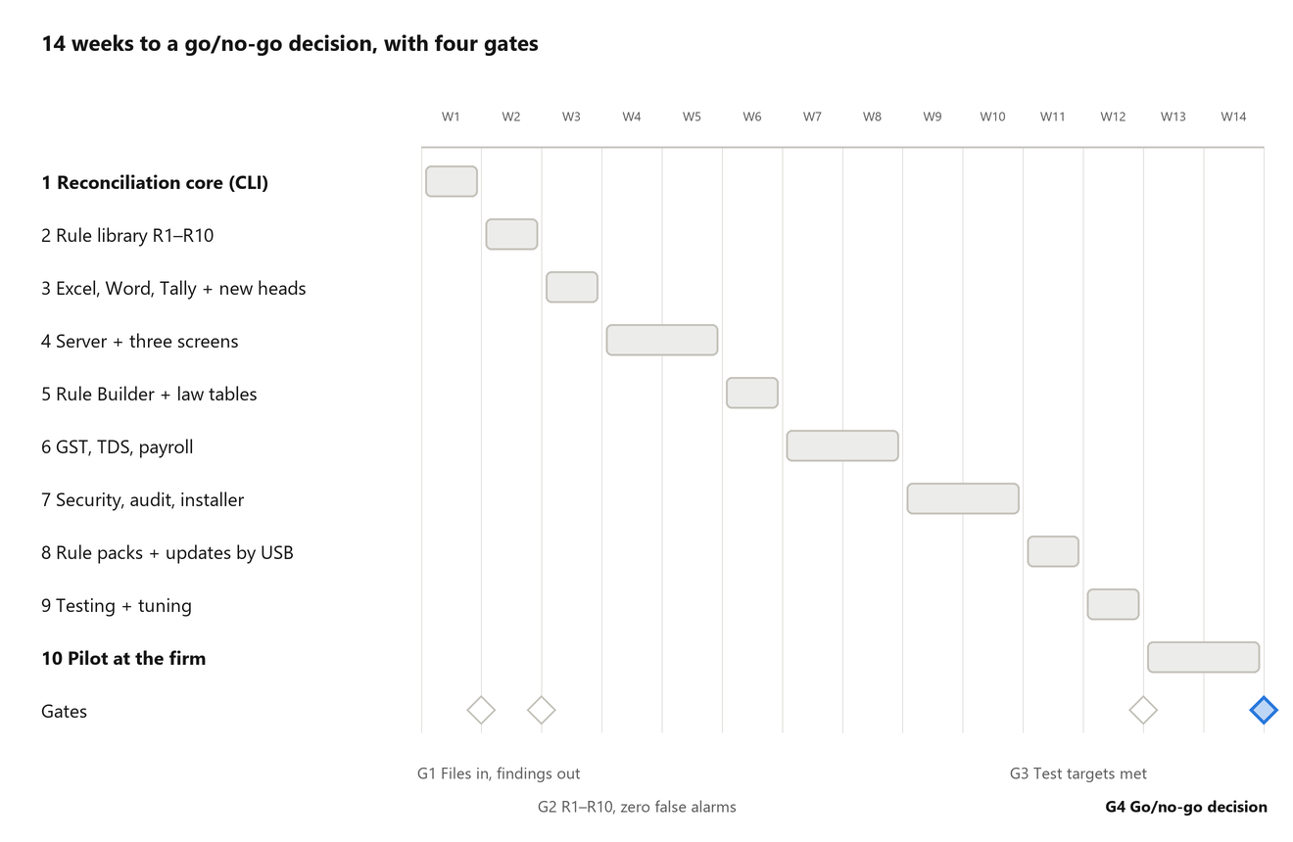
Phase 1 roadmap · 10 sprints, 4 gates
Weeks are counted from 13 Oct 2026. SPEC-002 and SPEC-003 are already Done, and SPEC-001 is waiting only for its first CI run. Durations assume full-time work; a sprint that misses its gate moves the later ones by a week.

Sprints and deliverables
Each sprint lists what gets built and the demo that proves it works. Sprints follow the spec order in specs/README.md. Requirement IDs refer to the BRD.
Sprint | Week | Build | Demo at sprint end | Requirements
1. Reconciliation core (command line) | 1 | SPEC-001 and 004 to 011: CI green; fact vocabulary; file ingestion with the JSON adapter; format profiles for the generic tax-suite files; SQLite fact store; strict YAML rule loader; hand-written rules; rule engine with the "equal" check; findings in a text and JSON report; recon-engine run command. No UI, no login, no voice | Reference pack in, findings out: the depreciation mismatch is reported with both values, the difference and both sources; clean pack gives zero findings; a missing figure gives "Cannot check" | FR-04 (JSON), FR-08, FR-09, FR-11, FR-12, FR-18, FR-19, NFR-03 to NFR-05
2. Rule library R1–R10 | 2 | SPEC-012 to 017: scalar check types; law tables with as-of-date lookup; Starlark formula rules; draft history and comparison; starter rules for R1–R10, each with a passing and a failing test file; determinism and performance harness | All ten reference defect types caught with zero false findings; two runs with shuffled input give identical output | FR-12, FR-17, FR-24, FR-29, NFR-05, NFR-07
3. Excel, Word, Tally and new heads | 3 | SPEC-018 to 021: Excel/CSV adapter; Word table adapter; Tally XML adapter and record store; year-on-year new-head detection and worklist; network-code check on each new library | Worklist built from two years of synthetic ledgers lists every new, vanished, broken-recurrence and step-change head | FR-04, FR-08, FR-09, FR-13
4. Server and three screens | 4–5 | SPEC-022 to 026: recon-server with login and roles; in-process job queue and engine supervision; clients, engagements, uploads and drafts; findings lifecycle and decisions; Season board, Client file and Worklist in the browser | Staff log in from a second PC, upload files, see findings grouped by document with the arithmetic, and decide them; a corrected upload resolves the finding | FR-01 to FR-03, FR-05 to FR-07, FR-20 to FR-23, NFR-13
5. Rule Builder and law tables | 6 | SPEC-027 to 028: rule and law-table governance; Rule Builder form; testing a draft rule on a past client; Format Register and vocabulary browser | CA creates a rule on the form and tests it on a past client; Partner activates it; the change appears in the rule history | FR-10, FR-25 to FR-29
6. GST, TDS and payroll | 7–8 | SPEC-029 to 033 and 044: record matching with date, threshold and period checks; PDF and fixed-width adapters; refusal of scanned PDFs and photos; GST, TDS and payroll modules | Gaps found on test GSTR, TDS, EPF ECR and ESIC files; a scanned PDF is refused, not guessed | FR-04, FR-14 to FR-16, NFR-14
7. Security, audit and installer | 9–10 | SPEC-034 to 040: SQLCipher encryption and key sealing; HTTPS, sessions and full role matrix; hash-chained audit log; backup and restore; Excel, watermarked PDF and client query letter exports; client export and deletion; Windows installer and portable zip | Security checklist passes; a backup is restored on a second machine; the installer sets up the tool on a clean Windows PC | FR-30, FR-32, FR-33, NFR-02, NFR-10, NFR-11
8. Rule packs and updates by USB | 11 | SPEC-041 to 042: signed content packs (verify, install, rollback, office-rule conflicts); binary updater | Signed pack installed from USB and rolled back; a tampered pack is rejected | FR-31, NFR-12
9. Testing and tuning | 12 | Run the full test set; measure speed with 200,000 vouchers and 50 clients; disable any rule that fires wrongly; fix failures; CA reviews the starter rules and law-table values | Test report against the BRD success criteria; CA sign-off on the rule library | NFR-07 to NFR-09, all FR
10. Pilot | 13–14 | Install on the firm's main desktop; staff run the tool on at least 5 real client files in the office; collect feedback; write go/no-go report | Go/no-go decision for production use and later phases | Objectives

Week 1: reconciliation core, day by day
The Week 1 target is the reconciliation process only: ingest the filing-pack files, run rules written by hand in YAML, and produce findings with both values, the difference and both sources. Each day ends with its specs' tests passing.
Day | Build | Done when | Specs
Day 1 | Close SPEC-001 (first CI run green). Fact vocabulary: the fixed list of figure names. Ingestion framework and JSON adapter that reads every amount as exact text, never as a decimal | CI green; JSON amounts read exactly; a malformed file is rejected with its line number | SPEC-001, 004, 005
Day 2 | Format profiles for the generic tax-suite computation and tax audit report files, with the profile test tool. SQLite fact store | The same file read twice gives identical facts; an unknown file is rejected, never guessed; 200,000 facts stored in under 10 seconds | SPEC-006, 010
Day 3 | Strict YAML rule format, loader and rule-lint. Write the first 5 to 10 rules by hand, starting with RECON-DEP-002 (depreciation) and other same-figure (R1) rules, each with a passing and a failing test file | A bad rule file is rejected with file and line; every rule loads and has both test files | SPEC-007
Day 4 | Rule engine with the "equal" check and the fixture runner. Finding wording and the report in text and JSON, grouped by the document that needs fixing | All rule fixtures pass; a missing figure gives "Cannot check", never a mismatch; the banned-word test passes; the depreciation finding matches its golden file | SPEC-008, 009
Day 5 | recon-engine run command end to end on the reference and clean packs. Testing and review agents go through every Week 1 spec; fix what they find; fill in completion records | Reference pack gives exactly the depreciation finding; clean pack gives zero; two runs give byte-identical output; engine dependency list has no network code | SPEC-011
Day 6 (buffer) | Finish anything carried over. If ahead, the Excel/CSV adapter, so Excel files are ingested too. It is taken ahead of spec order; its only dependency, SPEC-006, is already done | An Excel file holding the same figures gives the same findings | SPEC-018 (stretch)
Not built in Week 1
- No web UI, login or screens: the output is the command-line text report and the JSON report.
- No voice, no AI model, no Rule Builder, no Excel or PDF export, no rule packs, no installer.
- No GST, TDS or payroll modules yet; Week 1 checks the tax-suite filing pack only.
- No encryption yet: plain SQLite sits behind the same store interface until Sprint 7.

Prerequisites before Week 1
Most of these depend on the firm or on outside parties, so request them now even where they are needed later; each line says when. All samples are anonymised and kept outside the code repository.
- ☐ Claude Code plan with enough usage for full-day sessions plus parallel testing and review agents, needed from Day 1
- ☐ Windows test PC and a named person to run each build (Q5), needed by Day 5 to check the .exe
- ☐ CA available at the end of Week 1 to read the hand-written rules, then booked for rule and law-table review from Week 2 onward
- ☐ Name and version of the firm's tax suite, with anonymised JSON samples (Q1), needed by Week 2
- ☐ Anonymised samples of the Excel and Word documents staff prepare (Q2), needed by Week 3
- ☐ Tally version and written export steps (Q3), needed by Week 3
- ☐ Number of staff who will use the tool at the same time (Q6), needed by Week 4
- ☐ Decision on the finding states (including "withdrawn") and on who may disable a rule, needed by Weeks 4 and 6
- ☐ Anonymised GST portal, TRACES, EPF ECR and ESIC sample files, needed by Week 7
- ☐ Decisions on the HTTPS certificate on staff PCs and on keeping a licence check (Q4), needed by Week 9
- ☐ Main office desktop meeting the BRD minimum (8 cores, 16 GB RAM, SSD), two backup drives and a UPS, needed by Week 9
- ☐ Names of the pilot staff and the 5 real client files to be used in the pilot, needed by Week 13

Testing plan and go/no-go
A fixed set of synthetic test packs, run on every push from Week 1 and in full in Week 12, decides whether the product meets the BRD targets. The testing agent adds to it as each spec lands. No pack contains real client data.
Test set part | Size | What it checks
Reference filing pack with planted defects | 10 defect types (R1–R10) | Each defect caught, with both values, the difference and both sources (depreciation only in Week 1)
Clean filing pack | 1 pack | Zero findings
Packs with one figure removed | 1 per rule category | "Cannot check – figure not found" reply, never a mismatch
Drafts of one document | 3 drafts | Draft comparison and version regression (R10)
Ledgers for two years | 2 years | New, vanished, broken-recurrence and step-change heads in the Worklist
GST, TDS and payroll files | 12 GST returns, 4 TDS statements, 12 payroll files | Gaps, missing periods and late deposits found
Unknown formats, scanned PDFs and photos | 1 of each | Rejected with a clear message, never guessed
Large synthetic load | 200,000 vouchers; 50 clients | Speed targets, and identical results on a second run
Go to production planning if all of these hold
- All ten reference defect types caught with zero false findings.
- Fewer than 5 findings on a clean file, and fewer than 2 wrong findings per 100 in the pilot.
- The same files and rules, run twice, give identical results.
- One client under 3 minutes, 50 clients under 30 minutes, re-run after one changed file under 20 seconds.
- Every build's dependency list shows no network code in the engine, and the security checklist passes.
- The pilot firm runs the tool on at least 5 real files and confirms the findings are useful.
If a target is missed, the report names the cause and the fix, and the pilot repeats after one more sprint. A rule that fires wrongly is disabled, not tuned.

How to build with Claude
One developer drives the build with Claude Code, and two Claude agents, one for testing and one for peer review, check each spec before it is closed. CLAUDE.md and the specs/ folder are the single guide.
- Keep CLAUDE.md in the root of the GitHub repository and specs/README.md as the spec index and status tracker. Claude Code reads CLAUDE.md as project context.
- Start each session with: "Read CLAUDE.md and specs/README.md. We are on SPEC-0NN." Paste any error messages in full.
- Plan each 8–9 hour day against the Week 1 table or the sprint table. Pick the lowest-numbered spec whose dependencies are Done, ask Claude for one small, testable piece at a time, and commit to Git when the tests, gofmt and go vet pass.
- Testing agent (.claude/agents/test-engineer.md): after each piece, have it write the missing tests, run the suite and check the spec's acceptance criteria one by one. It reports every failure with its cause.
- Review agent (.claude/agents/code-reviewer.md): before the commit that closes a spec, have it review the changes. It only reads code and proposes fixes; the developer decides and applies them.
- Run the two agents in the background while starting the next piece, and clear their findings before moving to the next spec.
- The agents are peer review, not sign-off. A person (the CA, for rules and law tables) still re-runs verification before a spec is marked Verified.
- When a spec is finished, tick its acceptance criteria, fill in its completion record, add its files to docs/Tool1-File-Guide.docx and update its status, all in the same commit.
- Never paste real client data into Claude or the agents while building; use the synthetic packs only. Claude helps write code; it does not run inside the product and never decides a finding (NFR-06).

